**Grocery Management System**

**Gundrala Bharath kumar**

**Project Part**

**3rd April – 2022**

**Initial proposal**

Database Design for grocery management system is to help program the buying item, charging and to make the bought exchange quick with precision, to keep and get the sales records. It helps the employee and the owner to easily manage or control the exchange of the business. It will try not to exercise in futility just to compose all the significant data and information of the transaction and customer. My framework cycles and stores every one of the information or data of the business. This system is made using java with a relationship to Php/MyAdmin. The database of the system will store all the data like customer, employee, product, sales, and

payments. My simple silver cross grocery management allows the user to record the item or sales that are being reserved or ordered by the customer. On the Cashier system, the user or the authorized person can only login as a staff administrator.

**Relational Database Design Process**

For my business, I will have the following entities:

1.Customer info – Describes customer,ID#firstname,lastname,purchase

2.Employeeinfo –Describes Employee,ID#name,date of hired,Employee salary,job title

3.Product info –Describes product,ID#name,availability of product,price

4.Sales info –Describes sales,ID#first name,name of product,price,quantity,date of purchase

5.Payment info –Describes payment,ID#name,cost,stock,description of a product

**Customer Info**

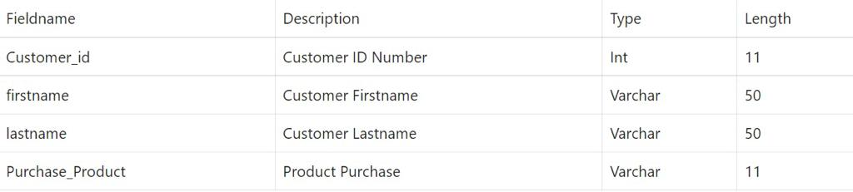

**Employee Info**

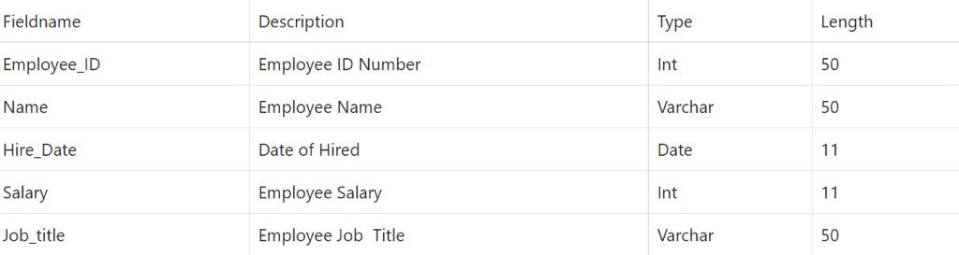

**Product Info**

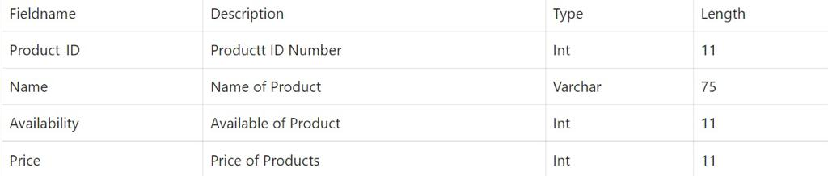

**Sales Info**

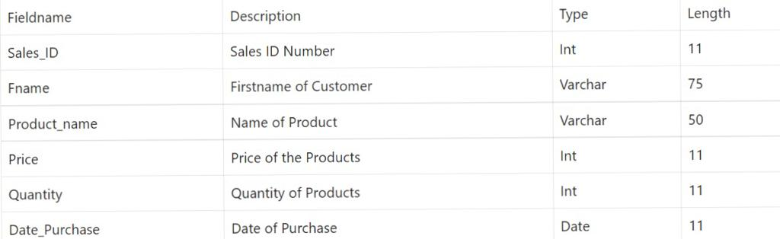

**Payment Info**

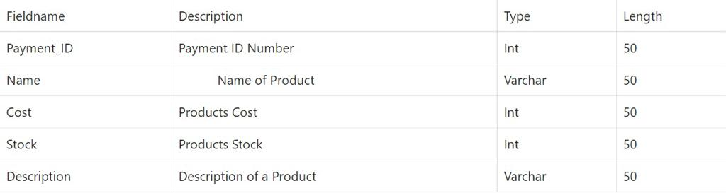

**UML ERD**

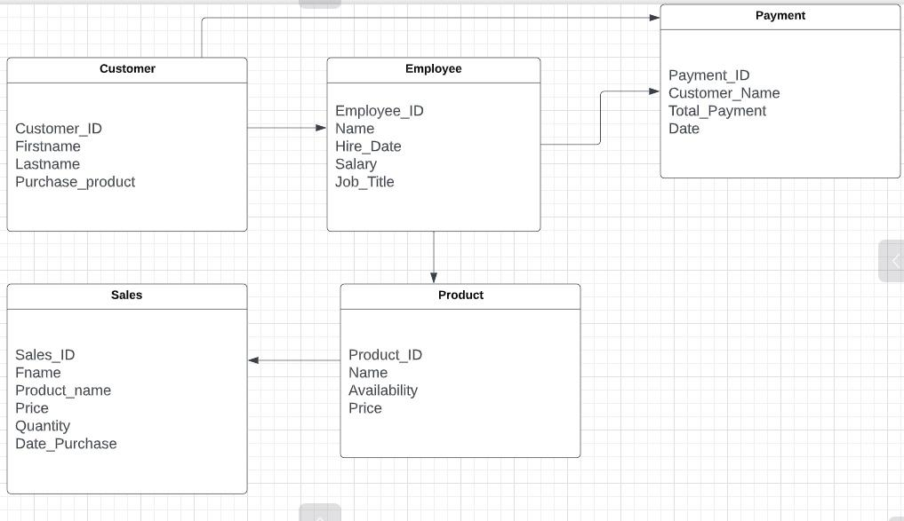

**Crows’s foot ERD**

